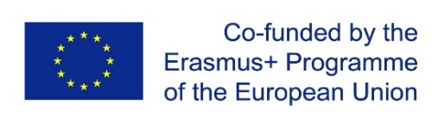

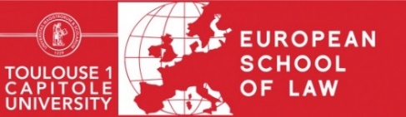

**Call for candidates**

**Applications should be sent before April 3, 2020**

The European School of Law Toulouse and its partner universities are organizing and hosting the **fifth edition of the Doctoral Workshops** **on Thursday July 2 and Friday, July 3 2020**at the Toulouse 1 Capitole University.

After the preceding themes of *General principles of law*, *Judicial creation of law and dialogue between courts*, *Citizenship*, and *The rule of law*, this edition of the doctoral workshops will cover the following theme:

***Compliance***

The objective of these workshops will be to better understand the concept of *compliance*, in all its forms, its complexity, and its multidisciplinary nature. *Compliance* calls on many fields of law, whether at the national, European, or international level. This includes its influence on economic actors, the sources of law, the effectiveness of law, or on relations between States and markets or private operators, this concept becoming more and more vital (whether it concerns competition law, environmental law, European Union law, business law, digital law, criminal law, tax law, international economic law, international private law, or international public law, this list not at all being exhaustive). The fifth edition of the Doctoral Workshops therefore should help advance discussions on the notion of *compliance* and the way in which it alters, changes, disrupts – or sometimes confirms or reinvents – traditional legal reasoning.

Contributions from all legal specialties are encouraged, the goal being to increase comprehension of the phenomenon of *compliance* through research that seeks to be resolutely interdisciplinary. This interdisciplinary aim should therefore help in taking advantage of the results obtained from other disciplines – both in the legal domain and outside of it – to offer a more detailed analysis of the consequences of *compliance* in each specific field considered.

The languages used for the Doctoral Workshops will be **French** and **English**.

Interested candidates must be enrolled in a doctoral program, and make a presentation that will be evaluated by the event’s Scientific Committee. The application must stipulate the presentation title, and provide a brief summary of its content (between 150 and 250 words), and include the candidate’s curriculum vitae, as well as a document certifying their enrollment in a doctoral program.

Applications must be sent by e-mail before April 3, 2020 to the following address: **esl@ut-capitole.fr**. The Scientific Committee will respond individually to each application, concerning its acceptance or non-acceptance, by e-mail.

If the application is accepted, the doctoral candidate must send a printed version of their presentation before Friday, June 26, 2020 (12-15 pages in length, 7,000 - 8,000 words), and present it publicly during the workshops, in a 15-minute time slot.

All contributions must be original works (not previously published). The final versions of the articles (8,000 words maximum, footnotes included) will be subject to the approval of the Scientific Committee.

The organization of the Doctoral Workshops and the publication of their presentations are co-financed by the European Union as part of the Jean Monnet Centre of excellence, a designation obtained by the European School of Law and the Research Institute on European, International and Comparative Law. The presentations will be published in the Cahiers Jean Monnet, a collection published by the Presses universitaires de Toulouse 1 Capitole.

Registration is free of charge. The European School of Law of Toulouse 1 Capitole University will provide coffee breaks, as well as the closing banquet that will take place on **Thursday, July 2, 2020**. Each participant is responsible for paying their own travel and accommodation expenses.